**Dalhousie University Halifax**

**Master in Internetworking**

2015-2017

**EDUCATION**

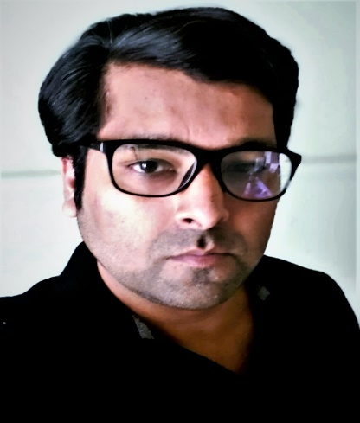

**Zeeshan Ahmad**

**DOB: Oct 23,1988**

**PROFILE**

Strong experience delivering and operating large, distributed, and resilient (**micro-services**) software systems in cloud environments such as **Kubernetes.**

Extensive experience with **Linux** administration and tuning (Ubuntu, CentOS, RHEL).

Proficiency in building and running apps within **Docker.**

Strong experience in **Automation** tools such as Helm, **Ansible,** Puppet, and **Chef**.

Experience in **CI/CD** implementations (e.g. **Git, Jenkins**, **GoCD, GitLAB**, Nexus) to develop the fully automated CI/CD pipeline

**1** year of **DevOps** experience in highly complex environments. Also Experience with Kafka

**A.K. Technical University Lucknow**

**Bachelor in Electronics & communication**

2006-2011

**National institute of fashion technology**

**Diploma in fashion technology**

2014 July -December

**EXPERIENCE**

**CONTACT**

**Coding Brains Pvt. ltd**

**DevOps Engineer**

2017 July – 2020 Nov

391-mail4.png

Zeeshan.ahmad1986@hotmail.com

**Job duties:**

Built and deployed Docker containers to break up monolithic app into micro services, improving developer workflow, increasing scalability, and optimizing speed.

Managed GitHub repositories and permissions, including branching and tagging.

Manage recipes & cookbooks in chef and playbooks in Ansible

Actively manage, improve, and monitor cloud infrastructure on AWS, EC2, S3, and RDS, including backups, patches, and scaling.

Network configuration of each virtual machine & Troubleshoot the VMs of client's template in vSphere.

Inspection of VM's operating systems (windows & Linux), Worked on SNS, CloudWatch, VPC, & manage IAM

067-phone.png

+12049965416

001-home.png

51- Arizona Drive ,Brampton ON

L6Y 0R6 Canada

202-sphere.png

[www.Wafzee.com](http://www.Wafzee.com)

016-camera.png

**HOBBIES**

Photography

032-book.png

Learning

Cooking

Travelling

**Job duties**:

Create users & roles in the storage and run the policies on the cloud through Identity Access Management and Active Directory.

worked on SNS, CloudWatch, Auto scaling & load balancer also worked on VMware-vSphere.

Handling a team to perform Installation of OS, up-gradation & troubleshooting of computers and printers remotely.

**Amazon Web Services -**Solution Architect Associate,

**Google Cloud Platform** - Cloud Fundamentals.

**Aviatrix** -Multi-Cloud Network Training - Associate.

**ICSI** -Certified Network Security Specialist.

**Fortinet-**Network Security expert   NSE-2.

**CISCO**- Introduction to IoT.

**ALIBABA CLOUD**-Fintech fundamentals

**AL Scrum foundation-** Professional Certificate

**CERTIFICATIONS**

**Radiance Web technology**

**System Administrator**

July 2011 -2014 December

**AWARDS & ACHIEVEMENTS**

**INTERNSHIPS**

**Best collage project of the year 2017**

**Microsoft-Engineering: undergraduate** and master’s Virtual internship.

**KPMG Canada:** Data Analytics Consulting Virtual Internship.

**BSNL New Delhi:** satellite communication& Radar system.

I have got the prize for my Master's Internetworking project named **"CRYPTOGRAPHY** " in DALHOUSIE University Halifax, Canada.

**TECHNICAL SKILLS**

**Cloud**=Extensive experience in Design, Development, Application Maintenance & Cloud Computing, Load Balancer, VPC. Autoscaling’s, Cloud watch, create users & roles in the storage and run the policies on the cloud through IAM, GitHub and Docker management

**Virtualization**=Inspection of VM’s operating systems (windows & Linux). Network configuration of each virtual machine. Troubleshoot the VMs of client’s template in vSphere.

**Networking**=Hands-on experience in Switching, Routing, Network troubleshooting.

Cisco routers (Lab experience)-1900, 2951, 3900, BGP, OSPF, RIP, EIGRP DHCP TCP/IP DNS.

**Applications**=MS Office 2003, 07 & 10(Word, Excel, PowerPoint), paint etc. Handling a team to perform Installation of OS, up-gradation & troubleshooting of computers and printers remotely.